Moringa School

AI Essentials and Workflow Automation Course

Automated Forex Intelligence & Pricing Platform

Week 10 capstone project

Project Report

Submission Date: 8th June 2026

Prepared By:

Maryanne Kinyanjui

Paul Wahome

Simon Njuguna

Table of Contents

1. Project Overview 3
2. Project Objectives 3
3. Architecture Diagram 4
4. Workflow Explanations & Node Configuration Screenshots 5
5. Error Handling Workflow 16
6. Screenshot of Execution Logs 17
7. Step-by-Step Workflow Execution 18
8. Integrations, APIs, and Tools Used 18
9. Error Handling & Recovery Mechanisms 19

Project Overview
The Production-Ready Financial Insights Automation System is an AI-powered workflow automation solution developed using n8n to automate the retrieval, processing, validation, summarization, and reporting of financial intelligence data from multiple financial institutions and forex information sources.
The workflow was designed to simulate a production-grade financial intelligence reporting environment where financial data is continuously collected, validated, summarized using AI, and distributed through automated reporting channels.
Unlike a prototype workflow, the solution emphasizes:
- Structured AI outputs
- Operational reliability
- Fault tolerance
- Workflow validation
- Error recovery
- Governance visibility
- Automated reporting and archival
The workflow consolidates financial intelligence from multiple financial sources into a single comparison dashboard and automated financial newsletter.

Project Objectives
The key objectives of the project were:
- Provides hourly visibility of market forex rates.
- Enables Treasury to determine competitive customer rates.
- Supports profitability decisions through market benchmarking.
- Reduces manual rate collection activities.
- Improves accuracy through automated validation and error handling.
- Creates a reliable audit trail of historical forex movements.

Architecture Diagram
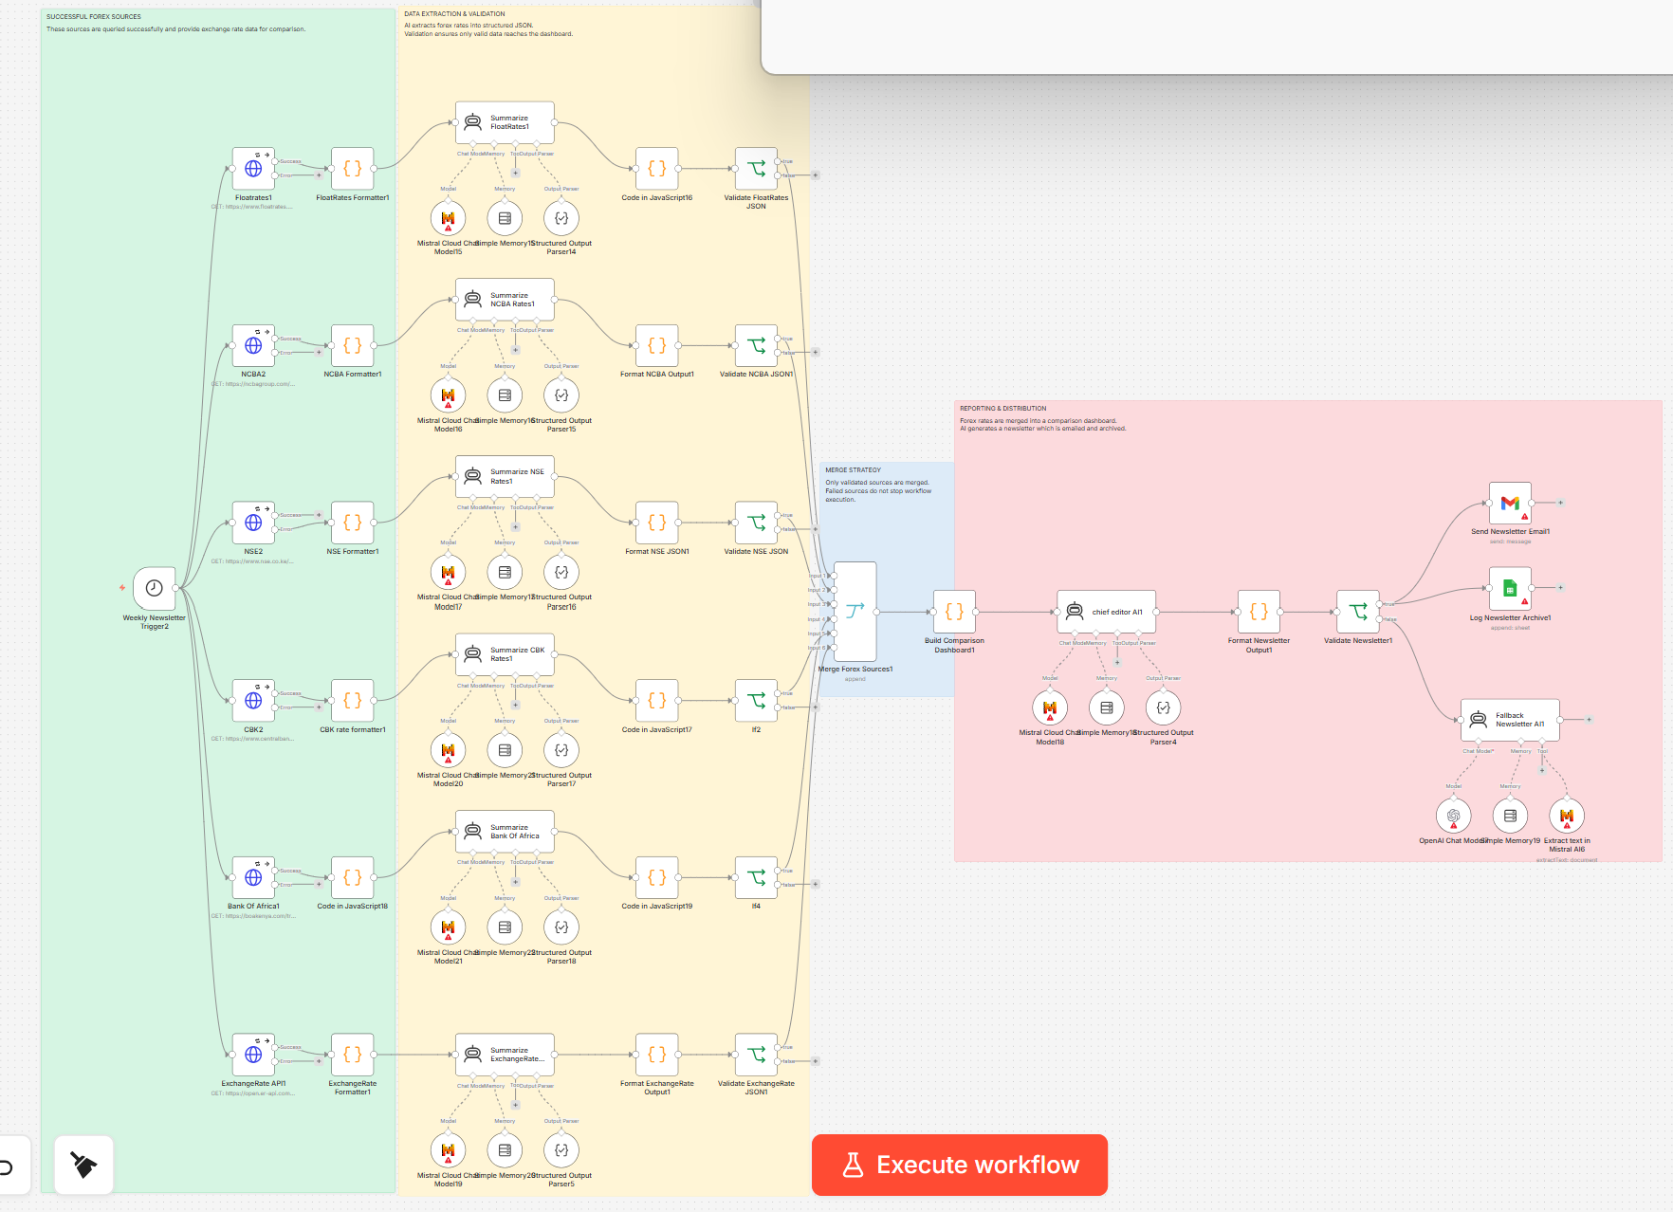

Workflow Zones
The workflow is organized into the following operational zones:
A. Successful Forex Sources Layer
Responsible for retrieving financial intelligence from multiple external sources.
B. Data Extraction & Validation Layer
Responsible for formatting extracted data, AI summarization, structured output parsing, and validation before merge.
C. Merge Strategy Layer
Responsible for consolidating only validated financial intelligence outputs.
D. Reporting & Distribution Layer
Responsible for dashboard generation, newsletter generation, validation, email distribution, and archival.

Workflow Explanations & Node Configuration Screenshots
Main Financial Insights Workflow
The main workflow performs the following operational steps:
Step 1 – Scheduled Trigger Execution
The workflow begins execution using a scheduled trigger node configured to run automatically.
Purpose:
- Automate periodic execution
- Remove manual intervention
- Simulate production scheduling
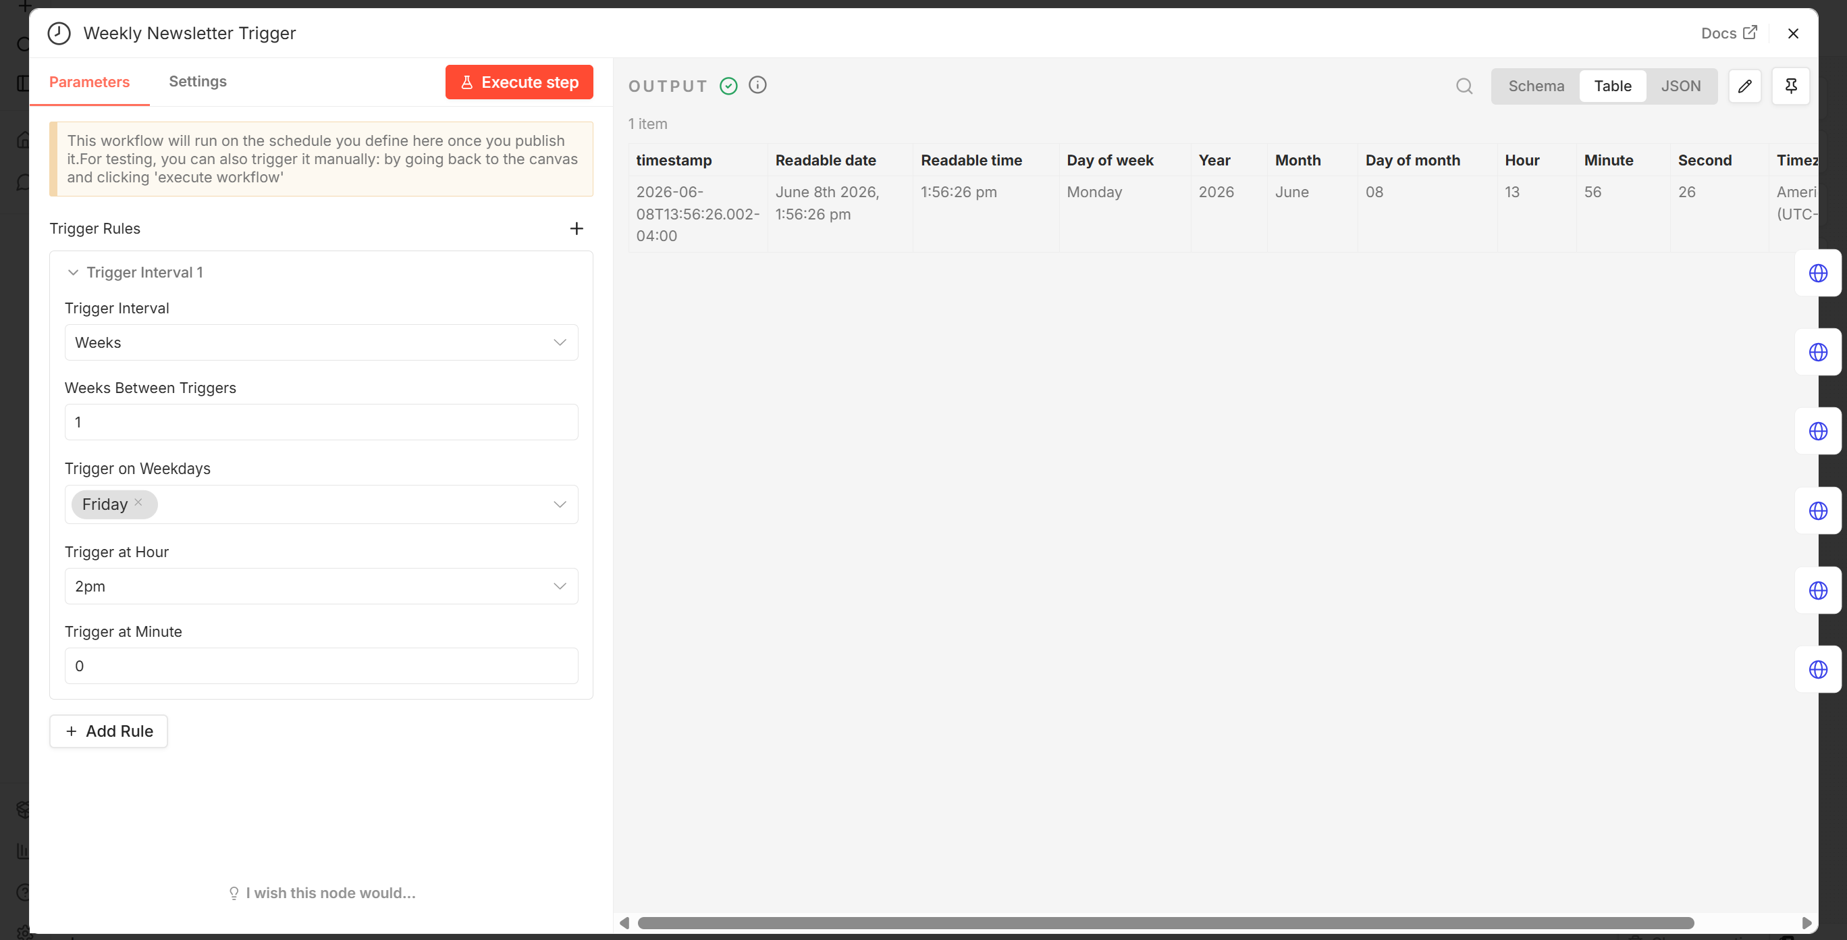
Step 2 – Financial Source Collection (HTTP Request)
The workflow retrieves financial intelligence data from multiple external financial sources including:
- FloatRates
- NCBA
- Nairobi Securities Exchange (NSE)
- Central Bank of Kenya (CBK)
- Bank of Africa
- ExchangeRate API
Each source operates independently to improve fault tolerance and branch-level isolation.
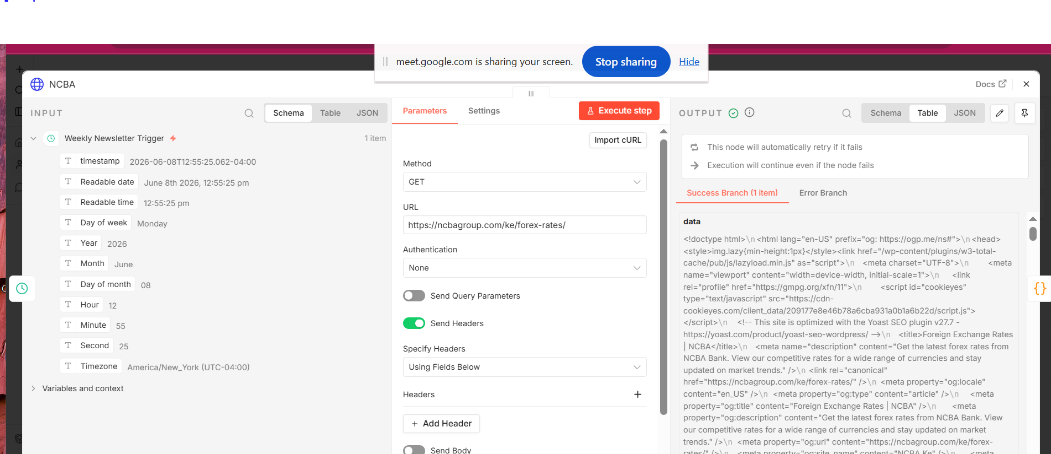
Step 3 – Formatter & Extraction Nodes
Each source passes through a dedicated formatter node responsible for:
- Cleaning raw HTML responses
- Extracting structured financial information
- Preparing content for AI summarization
- Normalizing source outputs
Formatter nodes include:
- FloatRates Formatter
- NCBA Formatter
- NSE Formatter
- CBK Rate Formatter
- Bank of Africa Formatter
- ExchangeRate Formatter
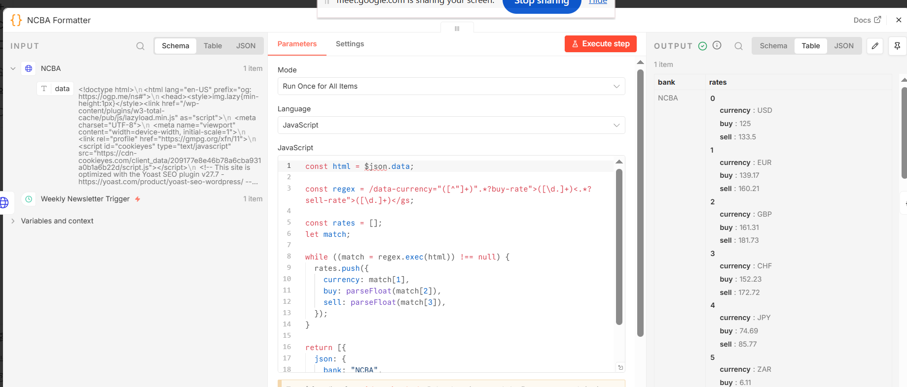

Step 4 – AI Summarization Layer
Each formatted source is processed through a dedicated Mistral AI summarization node.
Purpose:
- Generate financial summaries
- Produce structured outputs
- Normalize source intelligence
- Generate machine-readable outputs
The AI summarization layer uses:
- Mistral AI
- Structured Output Parser nodes
- Memory nodes where applicable

AI Agent User Message
Extract the top forex exchange rates against the Kenyan Shilling (KES).
Return ONLY valid JSON.
source = "FloatRates"
title = "FloatRates Forex Rates"
base_currency = "KES"
Include major currencies such as USD, GBP, EUR, ZAR, JPY, AUD, CAD and any other available currencies.
For each currency return:
- currency
- kes_per_unit
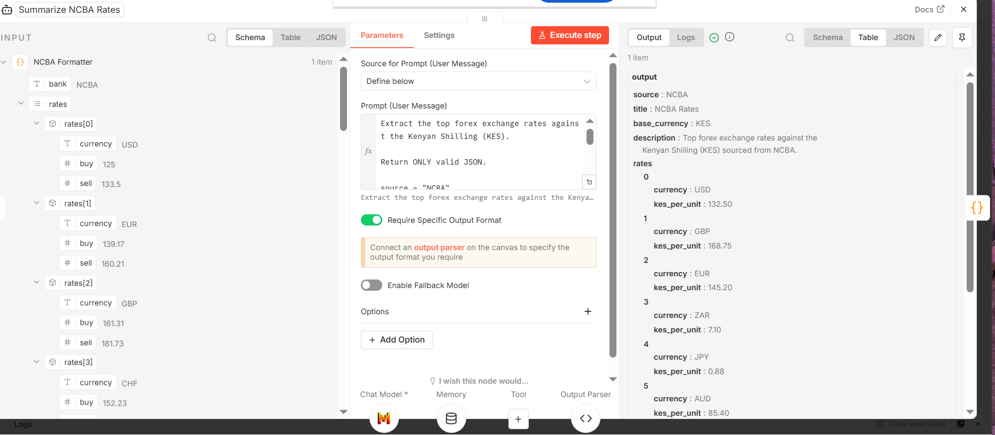

Step 5 – Structured Output Validation
After AI summarization, outputs pass through validation nodes.
Purpose:
- Prevent malformed outputs
- Enforce structured JSON reliability
- Ensure downstream compatibility
- Improve operational predictability
Validation nodes include:
- Validate FloatRates JSON
- Validate NCBA JSON
- Validate NSE JSON
- Validate ExchangeRate JSON
Validation logic ensures only valid outputs proceed into the merge strategy layer.
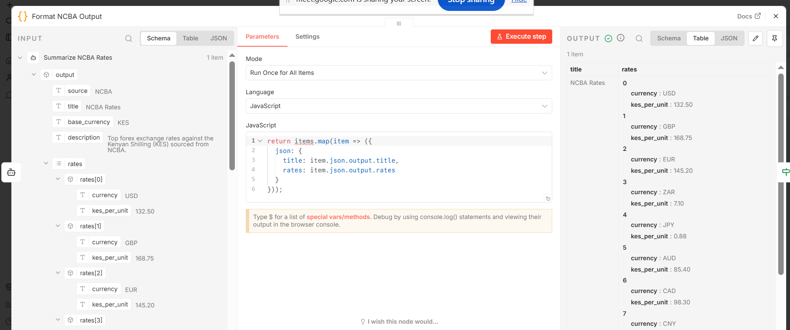

Step 6 – Merge Strategy
Validated outputs are merged into a centralized workflow path.
Purpose:
- Consolidate validated financial intelligence
- Prevent failed branches from stopping workflow execution
- Implement graceful degradation
The merge strategy ensures:
- Failed sources are isolated
- Workflow continuity is preserved
- Partial success execution is supported
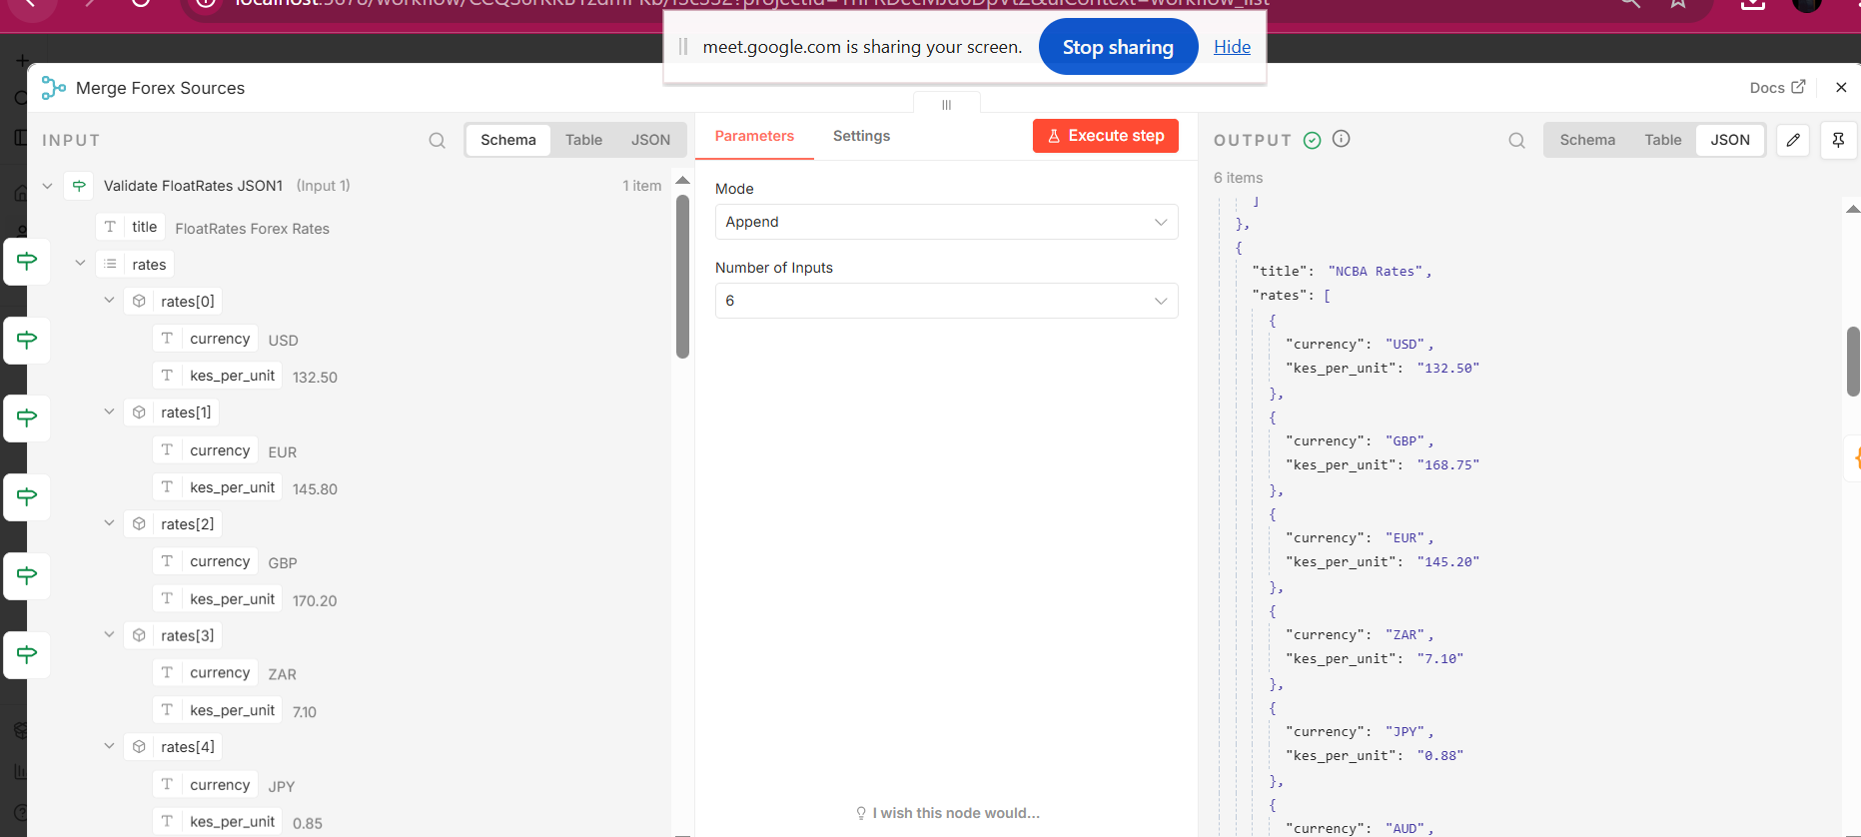

Step 7 – Financial Comparison Dashboard Builder
The workflow consolidates validated forex and financial intelligence data into a unified comparison dashboard structure.
Purpose:
- Create unified reporting structure
- Prepare dashboard table data
- Standardize final reporting outputs
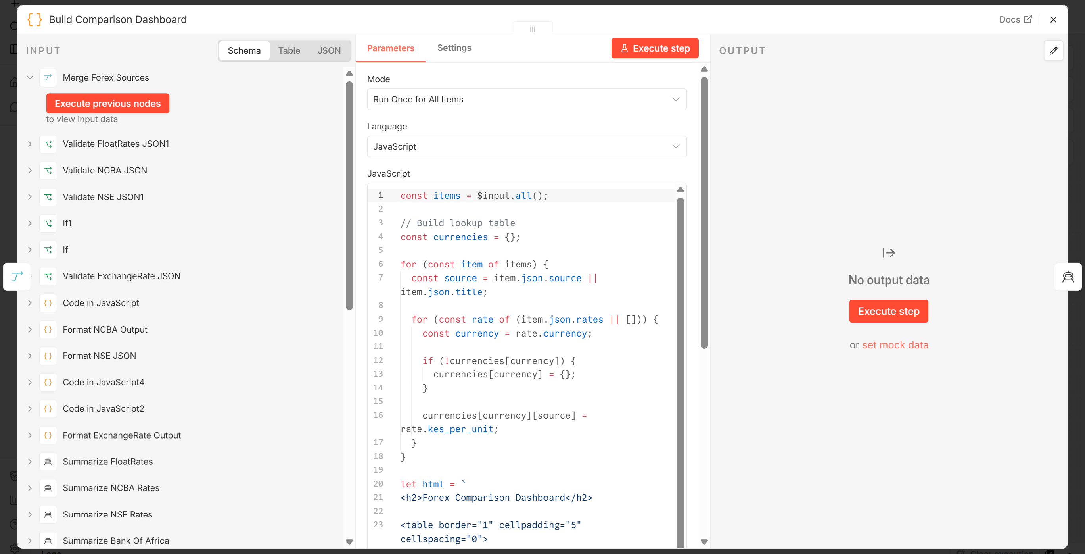

Step 8 – Chief Editor AI
A centralized AI node generates the final financial newsletter using merged financial intelligence data.
Purpose:
- Generate final financial summary
- Produce market outlook
- Consolidate financial insights
- Create final reporting narrative

User Message
You are the Chief Editor.
Review the forex comparison dashboard and create a concise financial newsletter.
Include:
- Headline
- Brief summary of key exchange rate observations
- Mention any notable differences between sources
Keep the newsletter under 200 words. Return valid JSON only.
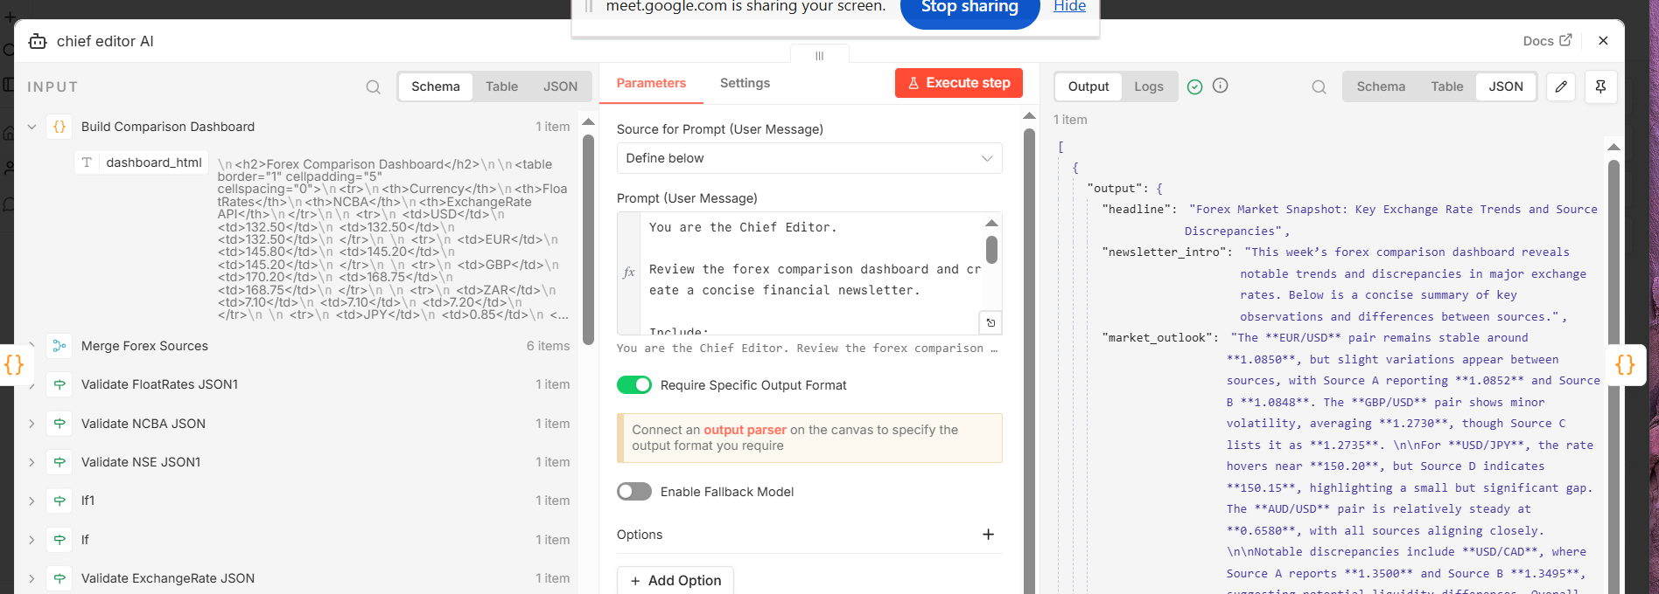

Step 9 – Newsletter Validation
The final newsletter output passes through validation checks before distribution.
Purpose:
- Prevent malformed newsletters
- Improve reliability
- Validate final structured outputs
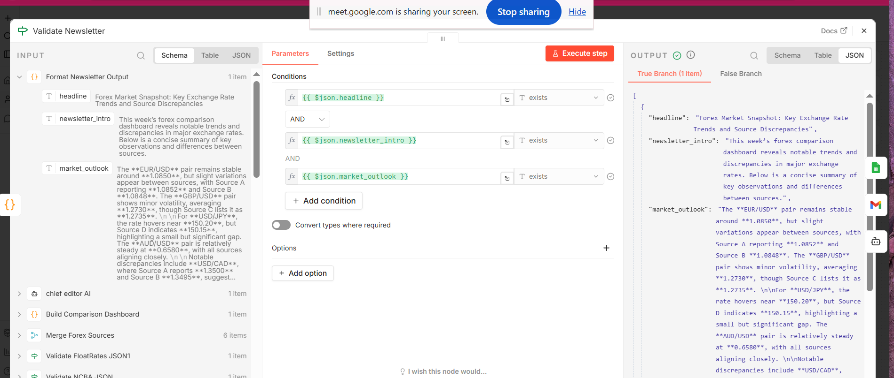

Step 10 – Email Distribution & Archiving
Validated newsletters are:
- Sent through Gmail
- Archived into Google Sheets
Purpose:
- Automated stakeholder distribution
- Governance visibility
- Historical archival
- Audit support
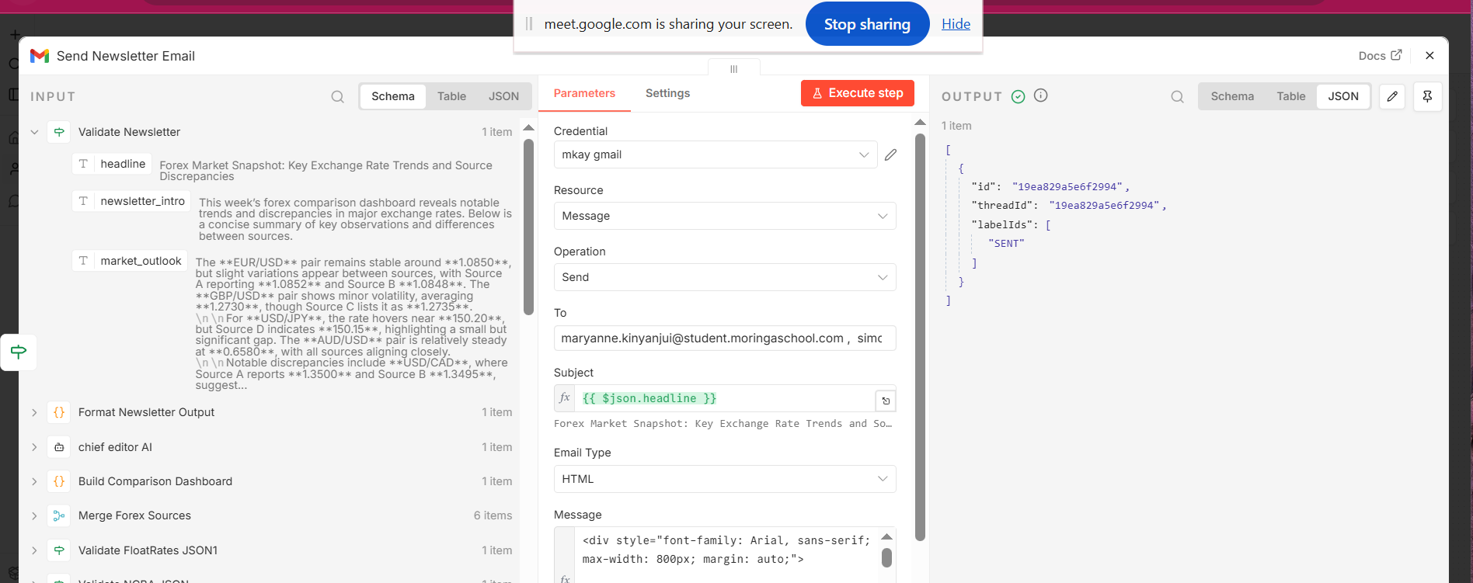
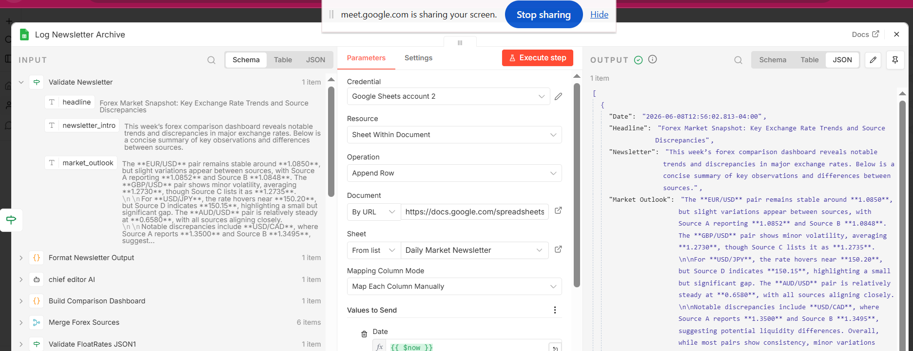
Step 11 – Fallback AI Handling
Fallback AI logic exists to support operational continuity in case of newsletter processing issues.
Purpose:
- Improve resilience
- Support recovery handling
- Prevent complete workflow failure

User Message
Generate a simplified newsletter intro using available summaries.
STRICT RULES:
1. Under 200 words
2. Plain text only
3. Use simple professional tone
4. Return ONLY valid JSON
Input summaries:
{{ JSON.stringify($json, null, 2) }}
Return ONLY valid JSON in this format:
{
"newsletter_intro": "string",
"word_count": number,
"model_used": "GPT-4o-mini",
"status": "fallback-success"
}
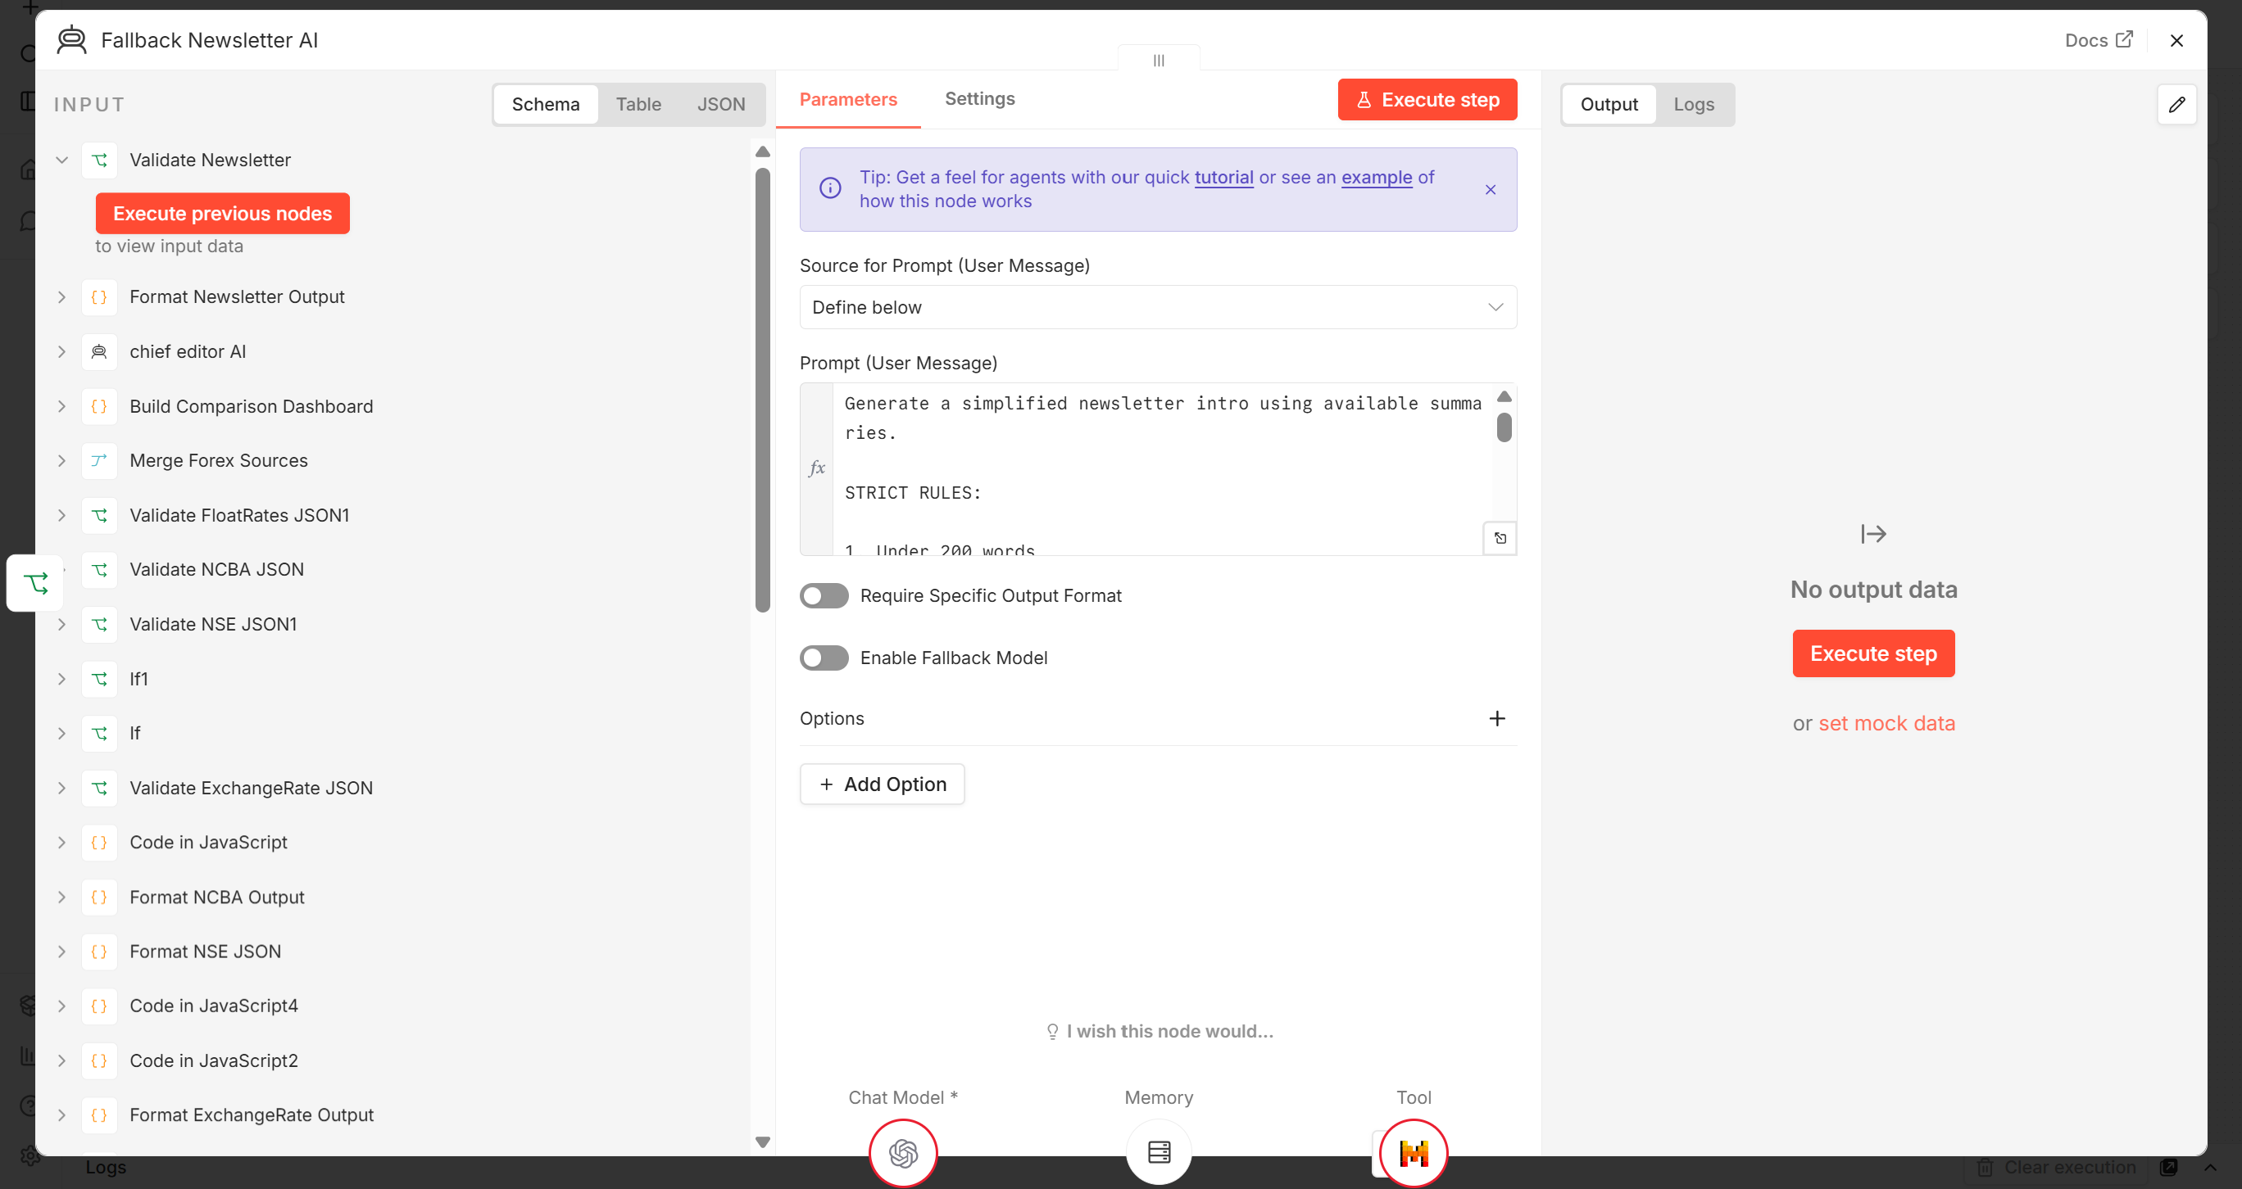

Error Handling Workflow
A dedicated Error Handling Workflow was implemented separately from the main workflow.
Purpose:
- Detect workflow-level failures
- Log operational errors
- Send automated notifications
- Improve operational visibility
The Error Handling Workflow performs:
- Error detection using Error Trigger node
- Logging into Google Sheets
- Gmail error notification delivery

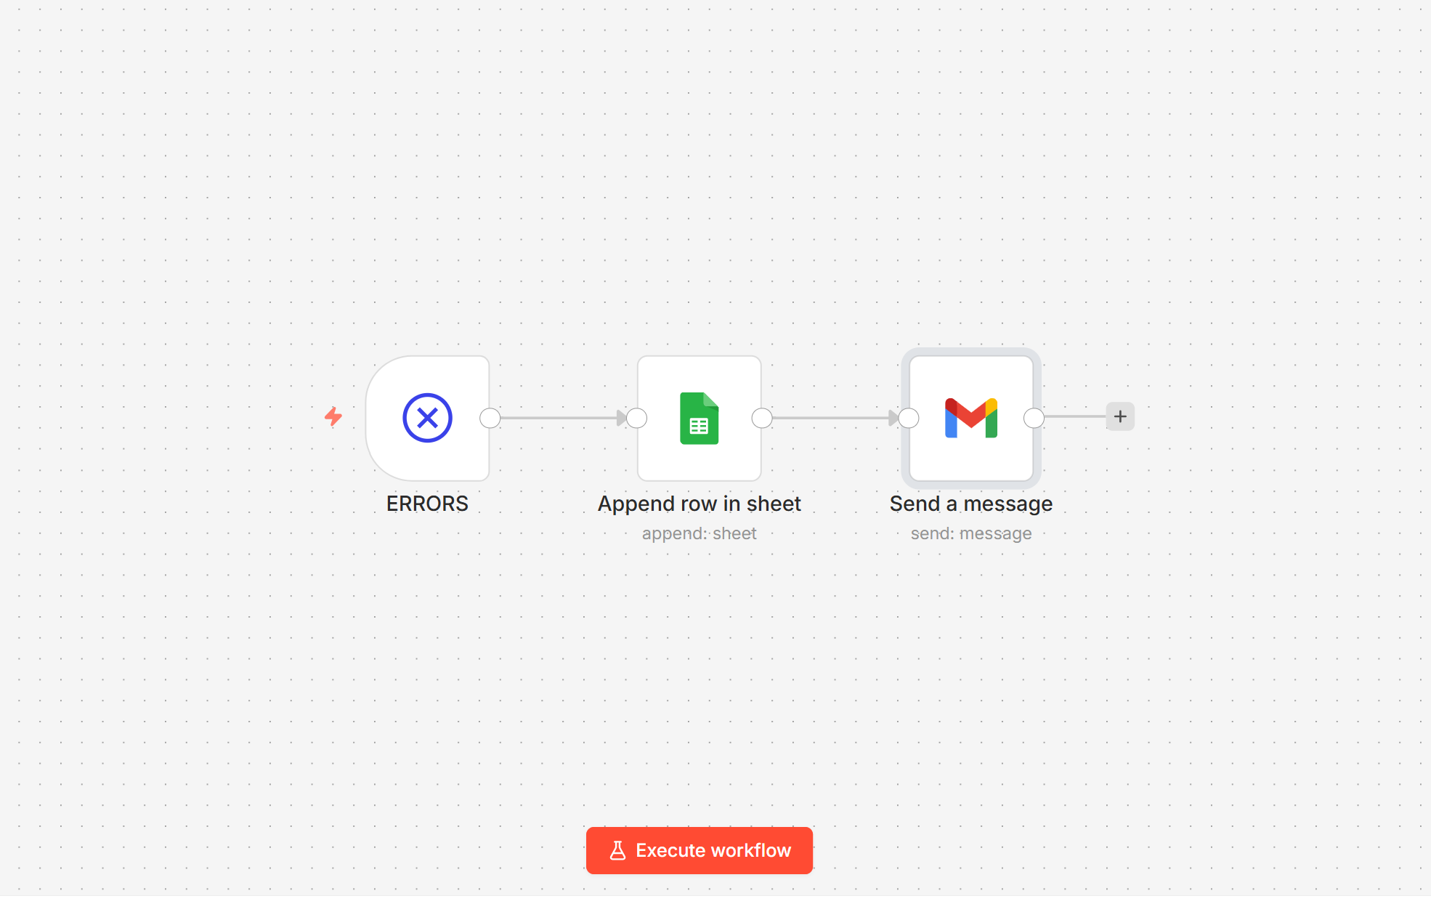

Screenshot of Execution Logs
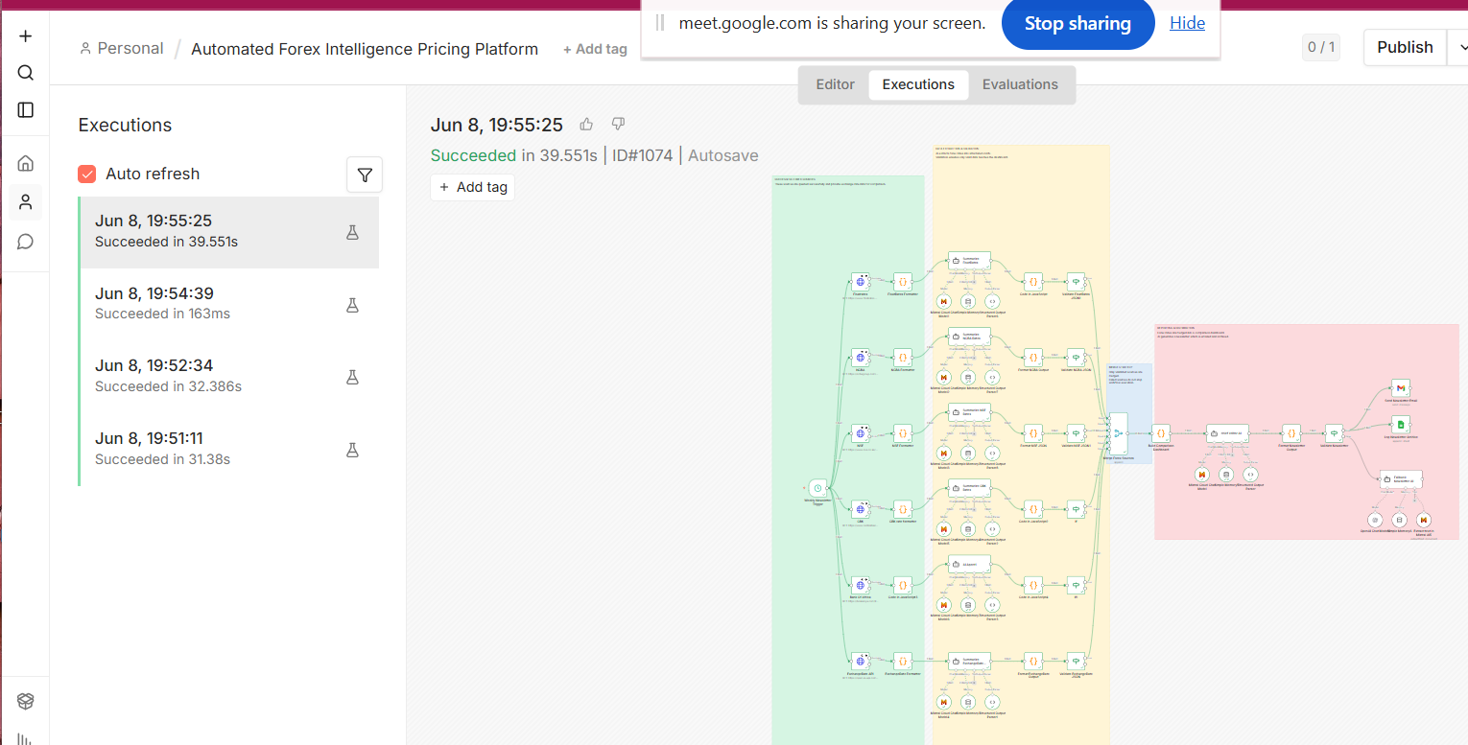

Step-by-Step Workflow Execution
- Scheduled trigger activates workflow
- Financial sources are queried independently
- Source formatter nodes clean and normalize outputs
- Mistral AI summarizes financial intelligence
- Structured output parsers validate AI outputs
- Validation nodes check JSON reliability
- Valid outputs proceed to merge layer
- Financial comparison dashboard is generated
- Chief Editor AI generates final newsletter
- Newsletter validation is performed
- Newsletter is emailed through Gmail
- Newsletter is archived into Google Sheets
- Fallback AI handling activates where necessary
- Error Handling Workflow activates during failures

Integrations, APIs, and Tools Used
Workflow Automation
- n8n
AI Processing
- Mistral AI
Email Distribution
- Gmail
Data Logging & Archival
- Google Sheets
Financial Data Sources
- FloatRates
- NCBA
- NSE
- CBK
- Bank of Africa
- ExchangeRate API
Programming & Data Processing
- JavaScript Code Nodes
- Structured Output Parser Nodes

Error Handling & Recovery Mechanisms
Continue-On-Fail Strategy
HTTP Request nodes were configured to continue execution even if individual financial sources fail.
Purpose:
- Prevent total workflow collapse
- Support graceful degradation
Branch-Level Isolation
Each financial source operates independently.
Purpose:
- Isolate failures
- Prevent cascading workflow errors
Structured Output Validation
AI outputs are validated before downstream processing.
Purpose:
- Prevent malformed AI outputs
- Improve machine reliability
Merge Validation Strategy
Only validated outputs proceed into the merged workflow path.
Purpose:
- Prevent invalid data propagation
- Improve reporting accuracy
Error Trigger Workflow
A dedicated Error Handling Workflow captures workflow-level failures.
Purpose:
- Improve operational monitoring
- Automate error logging
- Automate error notifications
Operational Logging
Workflow execution outputs and newsletter archives are stored in Google Sheets.
Purpose:
- Governance visibility
- Historical tracking
- Operational auditing

